Mrs. Lazuka’s TOP 5 HOLIDAY GIFTS FOR KEIKI
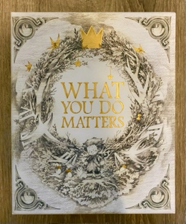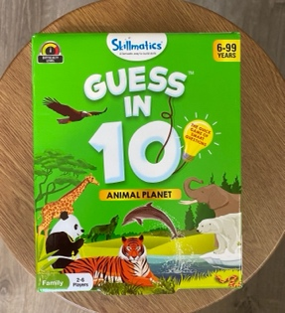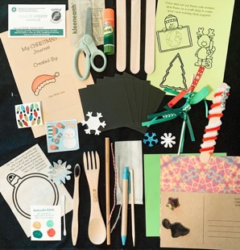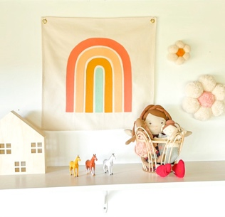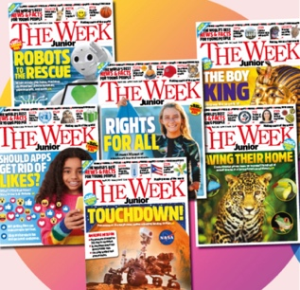

It’s a special time of year, especially for our keiki! As a long time educator and teacher, I’m so excited to share some of my favorite products that are keki approved and make the best gifts for the holidays!
- What You Do Matters Boxed Set Less than $30.00 on Amazon. A special forever keepsake that can be passed down within the Ohana. Includes three New York Times best-selling books for children of all ages! This charming box set will bring love and inspiration into your home. I also love how it sends a beautiful message; that all children can make a difference and that their dreams are always achievable. My absolute favorite book gift!
- Guess In 10 Animal Planet Game Ages 5-99. $14.00 Target, Amazon, Walmart. This game is simple, fun, and a family favorite! I enjoy playing it with my students and even with my husband! All my kiddos love anything that has to do with animals. Guess in 10, teaches children all about animal characteristics, habitats and cool facts. It also builds their reading and critical thinking skills! Win Win!
- Let’s Go Kiddo Holiday Kit $25.00. This eco-friendly holiday kit is hand crafted on Maui and includes a variety of local keepsakes as well as multiple crafts to keep your kiddo entertained and happy all day. All this fun comes inside a 100% composable zipper pouch to keep the materials stored. My students absolutely love all the unique and hand-crafted treasures from this gem of a little store! Enjoy! And enjoy local style! https://letsgotravelhappy.com/
- Palm and Petal Creative Hawaii designed and inspired room decor. These rainbows make a great addition to any nursery, bedroom, or space needing that instant boost of SUNSHINE! Palm and Petal knows that what goes inside your home matters. These products support the use of organic, sustainable, and non-toxic materials & practices. From product to packaging, Palm and Petal Creative keeps our planet in mind for generations to come! And they are gifting you 20% OFF all items this month! Discount code: GIFT20 Palm and Petal is offering FREE deliveries for everyone who receives this magazine! They also ship. Mahalo, Palm and Petal. http://www.palmandpetalcreative.com/

- The Week Junior magazine subscription. Ages 8-14 www.theweekjunior.com As soon as these magazines arrive at the door each week, my students are eager to open them up and start reading! The Week Junior is educational, fun, inspiring, and most importantly it gets keiki excited about reading! There is something in each magazine for every child to relate to and to learn from! Bonus: We all know how much kids love to receive mail in the actual mailbox! Extra Bonus: You can try six issues for FREE Highly recommend.

Wishing you a happy holiday season filled with Aloha,
Mrs. Lazuka

